Ms Ellis’s Yr4 Group –Zohra, Hadi, Negah, Ali, Wajahat, Tyrone, Latoya, Quinta
Thursday May 14 | Friday May 15 | Monday May 18 | Tuesday May 19 | Wednesday May 20
Speaking and Listening- House and Things  *Before listening to the sound grab today click on to the QUIZ tab so you cannot see the script of what the people are saying.  http://www.elllo.org/english/grammar/L2-04-AimeeTodd-House-HowMuch-many.htm  You will need to press the small ORANGE triangle play button  Listen to the audio “House and Things” It goes for 3.37mins  . Have the QUIZ tab open as you listen to the audio and you can pick your answers.  Don’t forget to CHECK your answers. Email Mrs Ellis or your class teacher to tell them your score. | Speaking and Listening  This is the same as the listening task we do in school.  Ask a parent or family member to help you.  60357  46985  78750  43968  10198  37910  Challenge  115930 | Speaking and Listening- Big Yellow Taxi 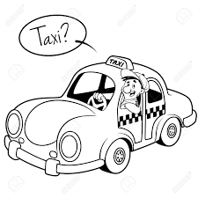  https://www.esolcourses.com/content/topics/songs/various-artists/big-yellow-taxi.html  Listen to the song.  Use the words from the pink box to fill in the missing words. | Speaking and Listening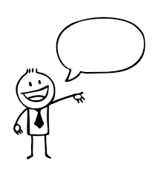  Persuasive speech.  Read your writing from yesterday “Children must wear uniform at home” to a grown up in your home. Use a clear, strong voice to help persuade your family to think like you. Remember to look at the people you are speaking to and use your face to show how you feel. | Speaking and Listening-What are they asking? 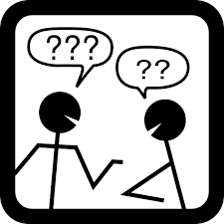  Look at the pictures. Think about the characters. Who is speaking? Come up with a QUESTION they might be asking.  We can tell they are asking a question because there is a ? in the speech bubble. Tell someone at your home.  Did they think of the same question as you?
Reading  https://www.esl-lounge.com/student/reading/1r5-the-1990s.php The 1990s  This story may be hard for some of you. If it is just do your READING EGGS work today.  If you are in Mrs Ellis’s EAL group I would like you to have a try with my reading activity before you do Reading Eggs.  Read the short story and answer the questions. Choose from the answers below to fill the box. Be careful, they are not in order!  How long he get America with What time did did he work to university How long did  his family  (Also do your Reading eggs work for your class teacher!) | Reading.  Recount 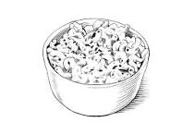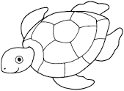  (Different students will have different texts. “Koala Park” “Macaroni Cheese” “Turtle Journal”)  Read the recount worksheet and answer the questions on the worksheet.  See if your recount has sequence words like THEN, NEXT, AFTER THAT. Underline them on the story page.  (Also do your Reading eggs work for your class teacher!) | Reading. -Recounts 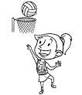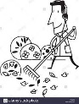  (Different students will have different texts. “Our day at the Fun Park”  “A Great Win” “A Clean Weekend”)  Read the text and answer the questions on the worksheet.  (Also do your Reading eggs work for your class teacher!) | Reading 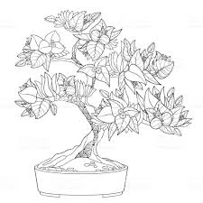  Storyline online  https://www.storylineonline.net/books/the-empty-pot/ or Google- Rami Malek The Empty Pot Youtube.  In your work book draw a 6 part story map to show the main parts of the story in order.  (Also do your Reading eggs work for your class teacher!) | Reading- Giant Pandas  https://www.esolcourses.com/vocabulary/learn-english-with-pictures/giant-pandas.html  Read the short article about Giant Pandas. At the end it asks you to think about why grown-up (adult pandas do not climb trees). Now look at the video of the panda to learn the answer.  Your choice- you can do the word game (put the words in ABC order) or the word search tab.  (Also do your Reading eggs work for your class teacher!)
.Writing  Recount  A Recount can be one of the easiest texts to write, especially if you are writing a true (non-fiction) recount about something that has happened to you.  Recounts have 4 main sections  Title  Orientation (When, who, where why)  Sequence of events (often using first, next, then, after that, finally)  Conclusion (what you thought or felt)  Recounts are written in PAST TENSE  Does it have all 4 sections?  Write your recount with the “When I went Shopping” in your workbook. (don’t forget the date)  If you need help look at Mrs Ellis’s recount on the back of this page.  Don’t forget to re-read and edit your work. | Writing  Imaginative Recount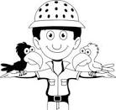  For this story you must imagine or pretend that you are a zookeeper.  Watch https://www.youtube.com/watch?v=bIjQ4tAi49M  Use the notes on the back of this page to help you write your recount. You will need these words  First Next Then Later After that Finally  Remember- for this story YOU are the zookeeper so your “Orientation” might look a bit like this.  “Every day I work at the zoo as a zoo keeper. I have many different jobs to do.”  First I  Next I  Then it is etc  Write your recount in your workbook or write it as a WORD DOCUMENT on your laptop. Don’t forget to put the date on your work. Send a photo of your work or email it to Mrs Ellis or your class teacher. | Writing- Persuasive text revisited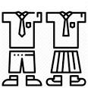  Today you will write a Persuasive text- You have had 2 weeks’ practice so you will be great.  Children must wear their school uniform while learning at home.  This writing will be a little bit different. You will choose one reason from the FOR side of the table and then one from the AGAINST side. You will need to include both sides into your writing today.  See my example if you need help.  FOR (why you should) AGAINST (why you shouldn’t)  Wearing school uniform gets you ready for learning. Wearing your own clothes or pyjamas is comfortable while you are learning.  It saves washing. If you wear your uniform every day you only have to wash one or two times each week. Most of the time your teacher can’t see you when you are learning at home so it wouldn’t matter if you don’t have uniform.  The Dandy West uniform looks great and keeps you warms o you won’t need to put the heater on at home. You look silly wearing school clothes when you are not at school.  Type your story on computer-as a Word document and email it to your teacher. | Writing- Persuasive  We should be able to keep our laptop at home forever.  For Against  Laptops at home mean we could learn things even when it is not school time. Kids would play games all the time and their eyes and backs would get sore.  Our families could use the laptop too for online shopping and talking on Skype. Little brothers or sisters might break the laptop and they cost a lot of money.  The teachers could stay at home and just teach students remotely. The laptops don’t belong to the students they belong to the school and when we leave school the laptop needs to go to someone else. | Writing- Tenses 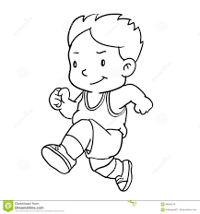 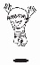 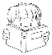  You looked at Tenses last Friday too. Recounts are written in past tense.  Look at these sentences. Re-write each sentence in your workbook but change it to PAST TENSE.  Start each of your sentences with YESTERDAY.  Eg Today I will eat my lunch. Yesterday I ate my lunch.  Today I jump on the bed. Yesterday I jumped on the bed.  You change these sentences to PAST TENSE.  - Today I run to school. (Take care)  - Today I do my work.(Be careful)  - Today I brush my teeth.  - Today I read a book. (Be careful this is a tricky one)  - Today I watch TV.  - Today I wash my hands.  - Today I write in my book. (Tricky)  - Today I go to the shop. (Think)  - Today I paint the door.  - Today I see a cat. (Think)

